Fundamentals of Hypothesis Testing

Hypothesis : A claim or statement about a property of a population.

Keep in mind this common guideline to reasoning in statistics:

Analyze a sample in an attempt to distinguish between results that can easily occur and results that are highly unlikely.

Example :

ProCare Industries once provided a product called “Gender Choice” which, according to advertising claims, allowed couples to “increase your chances of having a boy up to 85%, a girl up to 80%.” Gender Choice was available in blue packages for couples wanting a baby boy and pink packages for couples wanting a baby girl. Suppose you conduct an experiment that includes 100 couples who want to have baby girls, and they follow the Gender Choice “easy-to-use in-home-system” described in the pink packaging. Using common sense and no real formal statistical methods, what should you conclude about the effectiveness of Gender Choice if the 100 babies include :

- 52 girls
- 97 girls

Components of a Formal Hypothesis Test :

- The null hypothesis (denoted by H₀) is a statement about the value of a population parameter (such as the mean), and it must contain the condition of equality and must be written with the symbol =.

H₀: 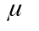= some value

Ex : The null hypothesis corresponding to the common belief that the mean body temperature is 98.6° F is expressed as : H₀ := 98.6

- The alternative hypothesis (denoted by H_{a}) is the statement that must be true if the null hypothesis is false. For the mean, the alternative hypothesis will be stated in only one of three possible forms :
H_{a}: 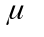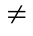some value
H_{a}: > some value
H_{a}: < some value

Note that H_{a} is the opposite of H₀. So, for example, if H₀ is given as = 98.6, then it follows that the alternative hypothesis is given by
H_{a}: 98.6.

Note about H₀

We conduct the test by assuming that the given mean is true. (Ex : = 98.6 is a true statement.)

Note about stating your own hypotheses :

If you are conducting a research study and you want to use a hypothesis test to support your claim, the claim must be stated in such a way that it becomes the alternative hypothesis, so it cannot contain the condition of equality.

Ex : If you believe that your brand of refrigerators lasts longer than the mean of 14 years for other brands, state the claim that > 14, where is the mean life of your refrigerators.

Note about Testing the validity of some else’s claim :

Sometimes you test the validity of someone else’s claim, such as the claim of the Coca Cola Bottling Company that “the mean amount of Coke in cans is at least 12 oz,” which becomes the null hypothesis of H₀: = 12. In the context of testing the validity of someone else’s claim, their original claim sometimes becomes the null hypothesis (because it contains equality), and it sometimes becomes the alternative hypothesis (because it does not contain equality.)

Errors in Hypothesis Testing

 |  | Null Hypothesis is  True | Null Hypothesis is False
DECISION | Reject the Null  Hypothesis  Fail to Reject the  Null Hypothesis | TYPE I error  Correct Decision | Correct Decision  1-  TYPE II error
1-

Significance Level : The probability of rejecting the null hypothesis when it is true(TYPE I error). Denoted with the symbol . The value of is typically predetermined, and very common choices are =0.05 and = 0.01. The symbol is used to represent the probability of a TYPE II error.

Test statistic : A sample statistic or a value based on the sample data. A test statistic is used in making the decision about the rejection of the null hypothesis.

Critical Region : The set of all values of the test statistic that would cause us to reject the null hypothesis.

Critical Value : The value or values that separate the critical region form the values of the test statistic that would not lead to rejection of the null hypothesis.

In the best situation, it would be nice to have and both equal 0. But in reality it is not possible, so we must attempt to manage the error probabilities. Mathematically, it can be shown that ,, and the sample size n are all related, so when you choose or determine any two of them, the third is automatically determined.

The usual practice in research and industry is to determine in advance the values of and n, so that the value of is determined.

The following are practical considerations :

- For any fixed , an increase in the sample size n will cause a decrease in . That is, a larger sample will lessen the chance that you make the error of not rejecting the null hypothesis when it’s actually false.
- For any fixed sample size n, a decrease in will cause an increase in . Conversely, an increase in will cause a decrease in.
- To decrease both and , increase the sample size.

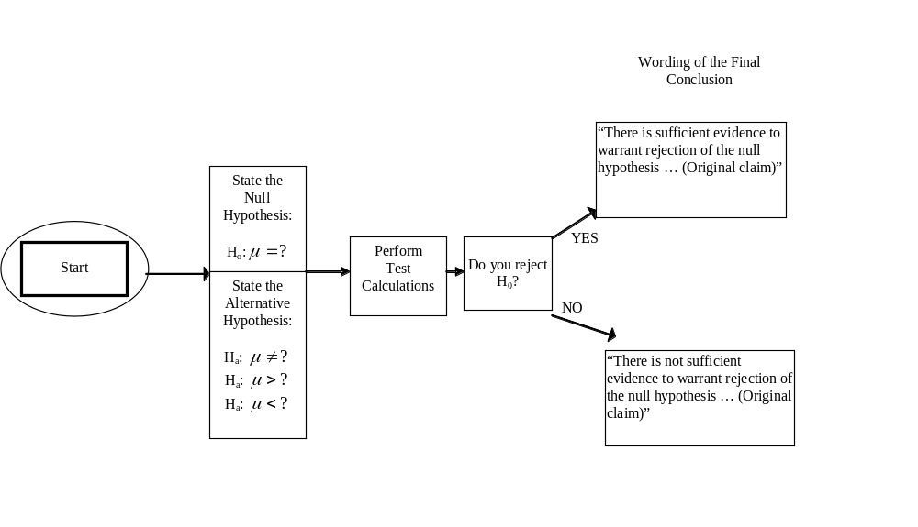
List and check assumptions
Calculate critical value or use p-value
Z-Test :

Population standard deviation is known
T-Test:

Population standard deviation is unknown

1-Prop Z-Test:

Given proportion

Traditional Method of Hypothesis Testing

- Identify the specific claim or hypothesis to be tested, and put it in symbolic form.
- Give the symbolic form that must be true when the original claim is false.
- Of the two symbolic expressions so far, let the null hypothesis H₀ be the one that contains the condition of equality. H_{a} is the other statement.
- Select the significance level based on the seriousness of a TYPE I error. Make small if the consequences of rejecting a true H₀ are severe. The values of 0.05 and 0.01 are very common.
- Identify the statistic that is relevant to this test and determine it sampling distribution.
- Determine the test statistic, the critical values, and the critical region. Draw a graph and include the test statistic, critical value(s), and critical region.
- Reject H₀ if the test statistic is in the critical region. Fail to reject H₀ if the test statistic is not in the critical region.
- Restate this previous decision in simple, non-technical terms.

Example :

The Jack Wilson Health Club claims in advertisements that “you will lose weight after only two days of the Jack Wilson Diet and exercise programs.” The Dade County Bureau of Consumer Affairs conducts a test of that claim by randomly selecting 33 people who have signed up for the program. It was found that the 33 people lost an average of 0.37 pounds. In the past, it has been proven that the standard deviation for weight loss is 0.98 pounds. Use a 0.05 level of significance to test the advertised claim. Assume that the population is normally distributed.

Solution :

- Perform a z-Test because population standard deviation is known.

H₀:= 0 The true mean weight loss is less than or equal to 0 pounds.
H_{a}:> 0 The true mean weight loss is equal to 0 pounds.
- Assume: - Simple random sample used to acquire data. (Stated in question)
- Population amount of weight lost is normally distributed. (Stated in question)
- 10n<N Population size is assumed to be large.
- With 0.05 significance level, we have = 0.05
- The test statistic is computed as follows :

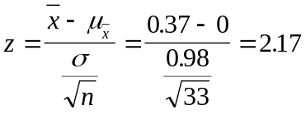

The critical value of z=1.645 is found as the score corresponding to an area of 0.95. (This test is right-tailed because the null hypothesis of 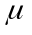 = 0 is rejected if the sample mean is greater than 0 by a significant amount.)
- We see that the sample mean of 0.37 pounds does fall within the critical region, so we reject the null hypothesis H₀.
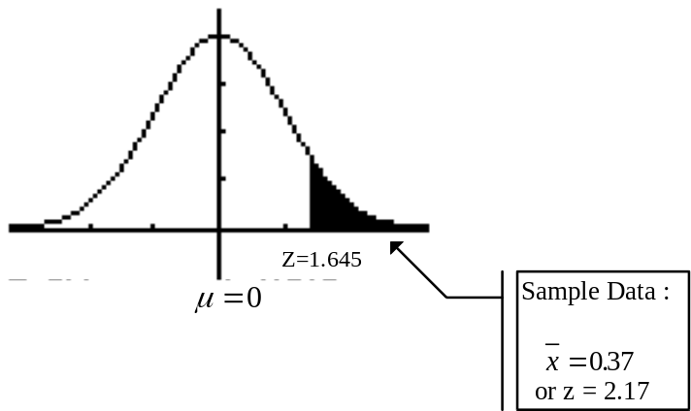
- There is sufficient evidence to support the claim that the mean weight loss is greater than 0 pounds. That is, the program does appear to be effective.

(But even though the result is statistically significant, it does not appear to have practical significance because the mean weight loss of only 0.37 pounds is very small.)
P-Value Method of Testing Hypotheses

P-Value : (Probability value) The smallest level of significance 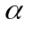 for which the observed data would call for rejection of the null hypothesis in favor of the alternative. For a given level of significance :

- reject H₀ if the P-value < level of significance
- do not reject H₀ if the P-value > level of significance

Use the following as a guide when writing conclusion :

P-Value | Interpretation
Less then 0.01 | High statistically significant  Very strong evidence against the null hypothesis
0.01 to 0.05 | Statistically significant  Adequate evidence against the null hypothesis
Greater than 0.05 | Insufficient evidence against the null hypothesis

Key steps and decisions that lead to the P-Value

Right-tailed Test | The P-Value is the area to the right of the test statistic
Left-tailed Test | The P-Value is the area to the left of the test statistic
Two-Tailed Test | The P-Value is twice the area of the extreme region bounded by the test statistic

The traditional method compares the test statistic to the critical values, whereas the P-value method compares the P-Value to the significance level.

Both the traditional and P-Value methods are equivalent in the sense that they will always result in the same conclusion.

